**Week of December 22 - December 28, 2024**

**Opportunities for Worship, Service, Study, and Fellowship:**

**Today:** Worship 10:45 am

Social Time and Snack after Worship

**Monday:**

**Tuesday:** Christmas Eve Service Sanctuary 5:30 pm

**Wednesday:** Christmas Day

WSAA Fellowship Hall 7:00 pm

**Thursday:**

**Friday:**  Pillows of Faith Garden Room 6 to 9 pm **Saturday:**

**Sunday:** Worship 10:45 am Social Time and Snack after Worship

______________________________________________________________________________

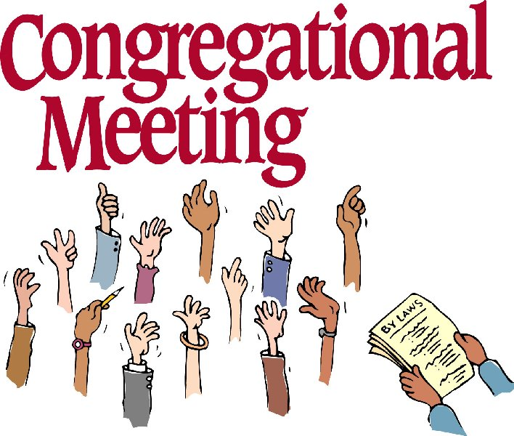

On January 8th we will have a congregational meeting to install elders

and give the end of year reports.

‘Murray Hill Presbyterian Church



Making His Purpose Count

940 Talbot Avenue

Jacksonville, Florida 32205

(904) 389-2939

[www.mhpcjax.com](http://www.mhpcjax.com)

[mhpcjax@gmail.com](mailto:mhpcjax@gmail.com)

Rev. Jesse Bozeman

December 22, 2024

**December 22, 2024**

Fourth Week of Advent

**Gathering God’s People**

Music for Gathering John Lansdale

Welcome and Announcements Rev. Samuel Bennett

**\*Call To Worship:**

Leader: Keep watch! For the One who brings peace is coming.

**People: We wait in anticipation for Christ.**

Leader: We wait for God’s revealing of joy. Remain alert!

**People: : Love is coming to dwell among us. Hope draws near.**

**Lighting of the Advent Candle of Love**

Leader: As we light our fourth Advent candle,

**People: we rejoice with Mary, for Love has flesh.**

Leader: Come now, O Child of Mary.

**People: Come now, O Prince of Love.**

**\*Song of Love:** Love Lifted Me #508

**Confessing Our Sins**

**Call to Confession**:

**Prayer of Confession (in unison)**

O God, giver of all good gifts, we come before you as children in need of your wisdom and grace. Our

fears and our hopes are braided together in the rhythm of daily life. Our visions of the future depend on

our own hands and ability. Our expectations remain reasonable and within our control. Break into this

tangle of fear and hope, bringing peace to our souls. Break into our vision of the future, returning us to

your hands. Break into our expectations, awakening us with curiosity and wonder; through Jesus Christ

our Lord.

(Observe a time of silence for personal prayers of confession) **Amen**

**Declaration of Forgiveness:**

Leader: Christ’s coming is certain. God’s promise is true. Trust in the transformational power of God’s forgiveness and receive the gift of God’s love. In Jesus Christ we are forgiven!

**People: Thanks be to God.**

**Passing the Peace of Christ:**

Leader: May the Peace of Our Risen Christ be with you!

**People: And also with you.**

(It is our custom to greet one another at this time using the words above)

**Song of Adoration (please find your way back to your seat as we sing together):**

**\*Glory be to the Father, and to the Son and to the Holy Ghost, as it was in the beginning is now and ever shall be, World without end. Amen. Amen.**

**\*Song of Worship:** *God Will Take Care of You*  #692

Pastoral prayer and Lord’s Prayer Rev. Jesse Bozeman

**Proclaiming the Word of God**

Scripture: Luke 1: 39 - 55

Message: “Song of Merry” Rev. Jesse Bozerman

**Responding to God’s Grace**

Offering of our lives and gifts Joy Offering will be taken up at this time.

Offertory Music John Lansdale

*Doxology (Owens Arrangement) #814

Prayer of Dedication Rev. Jesse Bozeman

**\*Sending**

**\*Song of witness:**  *Go, Tell It on the Mountain # 258*

Benediction Rev. Jesse Bozeman

Congregational Response: *The Family of God #419*

**\*Please stand for these parts of the service if you are able.**