**Week of December 29, 2024 -January 5, 2025**

**Opportunities for Worship, Service, Study, and Fellowship:**

**Today:** Worship 10:45 am

Social Time and refreshments after worship

**Monday:**

**Tuesday:**

**Wednesday:** Happy New Year

WSAA Fellowship Hall 7:00 pm

**Thursday:**

**Friday:**  Pillars of Faith Garden Room 6 – 9 pm

**Saturday:**

**Sunday:** Worship 10:45 am

Social Time and Snacks after worship

_______________________________________________________________________________

On January 5th we will be having a Congregational

Meeting after worship service in order to ordain and install elders and give end of year reports.

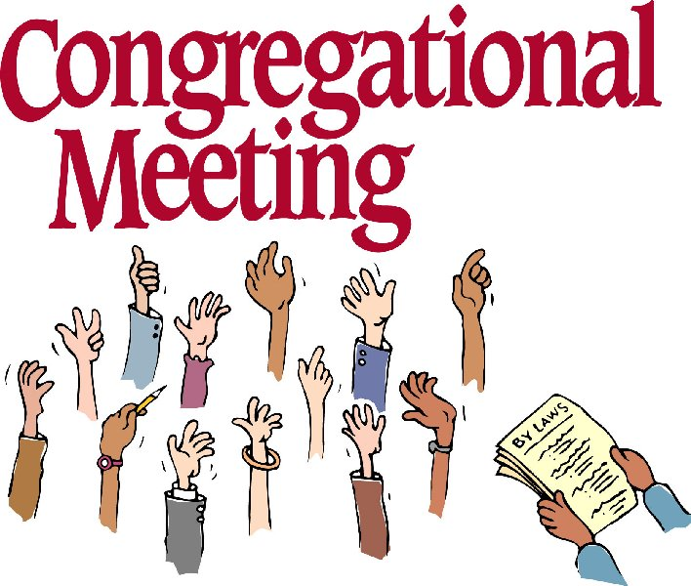

Notes

**Murray Hill Presbyterian Church**



**Making His Purpose Count**

940 Talbot Avenue

Jacksonville, Florida 32205

(904) 389-2939

[www.mhpcjax.com](http://www.mhpcjax.com)

[mhpcjax@gmail.com](mailto:mhpcjax@gmail.com)

Rev. Samuel Bennett

December 29, 2024

**December 29, 2024**

First Sunday after Christmas

**Gathering God’s People**

Music for Gathering

Welcome and Announcements Beth Bozeman

**\*Call To Worship:**

Leader**:** Let us praise the name of the Lord! God commanded and we were created. Leaders and followers, old and young, all of God’s beloved children, all people everywhere as with the angels, let us come and praise the exalted name of the Lord. Let us worship God.

**Song of Praise:** *How Sweet the Name of Jesus Sounds #123*

**Confessing Our Sin**

Call to Confession:

**Prayer of Confession (in unison)**

Holy God, though we are in awe of the dawn of your light in Jesus Christ, we remain self-centered and cling to the sin of the world. We celebrate the birth of our savior, yet we struggle in our commitment to follow him. We are called to pursue justice, love kindness, and walk humbly with you; yet we are content to seek our own comfort and conveniently ignore the cries of those in need. By the light of the Christ child, lead us on a path of goodness and righteousness, as we seek to love all of your bountiful creation.

(Observe a time of silence for personal prayers of confession) **Amen**

Declaration of Forgiveness:

We are God’s chosen ones, holy and beloved. The mercy of the Lord is from everlasting to everlasting. Know that you are forgiven and be at peace.

Passing the Peace of Christ:

Leader: May the Peace of Our Risen Christ be with you!

**People: And also with you.**

(It is our custom to greet one another at this time using the words above)

Song of Adoration (please find your way back to your seat as we sing together):

**\*Glory be to the Father, and to the Son and to the Holy Ghost, as it was in the beginning is now and ever shall be, World without end. Amen. Amen.**

Song Of Joy: *I Heard the Bells on Christmas Day #267*

Pastoral prayer and Lord’s Prayer Rev. Samuel Bennett

**Proclaiming the Word of God**

Scripture: Luke 12: 35 – 38 and Matthew 25: 1 - 13

Message: “Be Ready- Persevere”Rev. Samuel Bennett

**Responding to God’s Grace**

Offering of our gifts and pledges

Offertory Music

*Doxology (Owens Arrangement) #814

Prayer of Dedication Rev. Samuel Bennett

**\*Sending**

*Song of witness: *I’d Rather Have Jesus #506*

Benediction Rev. Samuel Bennett

Congregational Response: *The Family of God # 419*

**\*Please stand for these parts of the service if you are able.**