Week of March 8 – March 15, 2026
Opportunities for Worship, Service, Study, and Fellowship:

Today: Worship 10:45 am
Lenten Soup Luncheon after Worship John Lansdale
Committee Meeting after Lunch
Session Meeting after Committee Meeting
Monday: Christian Support Group Fellowship Hall 5:30 pm
Tuesday: AARP Tax aide Fellowship Hall 9- 4 pm
Wednesday: WSAA Fellowship Hall 7:00 pm
Thursday:
Friday:
Saturday: Workday 9:30 am
Luncheon Fellowship Hall around noon
Women’s Meeting Fellowship Hall After Lunch
Sunday: Worship 10:45 am
Lenten Soup Luncheon after Worship Mary Straining

_______________________________________________________________________________


We are collecting donations for One Great Hour of Sharing until April 2



We need Easter Lilies for the sanctuary. You may buy one at $15.00 or make a donation toward one. Please order as soon as possible so I know how many to order.

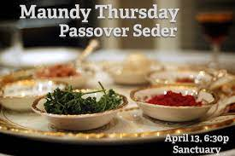
Don’t forget to put your reservation in for the Maundy Thursday Seder on April 17th. I hope everyone comes and brings a guest. This is a beautiful, meaningful service that I believe everyone could gain understanding from.

Murray Hill Presbyterian Church

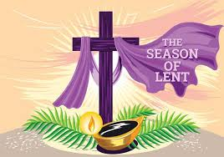

Making His Purpose Count

940 Talbot Avenue
Jacksonville, Florida 32205
(904) 389-2939
www.mhpcjax.com
mhpcjax@gmail.com

Rev. Samuel Bennett

March 8, 2026

March 8, 2026
Third Sunday in Lent
Music for Gathering John Lansdale
Welcome and Announcements Beth Bozeman

*Call To Worship:

Leader: O come, let us sing to the Lord; let us make a Joyful noise to the rock of our salvation!
People: We have come to give thanks and to sing songs of praise!
Leader: We are the people of God’s pasture; we trust that God will bring us through the wilderness.
People: We seek God’s living water and praise God’s holy name!

Opening Song: Take My Life, Lead Me, Lord #664

Prayer Of the Day

665

(Observe a time of silence for personal prayers of confession) Amen

Passing the Peace of Christ:

Leader: May the Peace of Our Risen Christ be with you!
People: And also with you.
(It is our custom to greet one another at this time with the Peace of Christ)

Song of Adoration (please stand and sing):

*Glory be to the Father, and to the Son and to the Holy Ghost, as it was in the beginning is now and ever shall be, world without end. Amen. Amen.

*Song of praise: O Master, Let Me Walk with Thee #665

Pastoral prayer and Lord’s Prayer Rev. Samuel Bennett

Proclaiming the Word of God

Scripture: Deuteronomy 30:19 Rev. Samuel Bennett
Message: “Turn Around”

Responding to God’s Grace

Offering of our gifts and pledges
Offertory Music John Lansdale
*Doxology (Owens Arrangement) #814
Prayer of Dedication Rev. Samuel Bennett

*Sending

*Song of witness: O Jesus, I Have Promised #676
Benediction Rev. Samuel Bennett
Congregational Response: What a Mighty God We Serve #672

*Please stand for these parts of the service if you are able.

