**Week of September 14 – September 21, 2025**

**Opportunities for Worship, Service, Study, and Fellowship:**

**Today:** Worship 10:45 am

Potluck Dinner after Worship

Session Meeting after Dinner

**Monday:** Christian Support Group Fellowship Hall 5:30 p

**Tuesday:**

**Wednesday:** Night Bible Study at Church 5:30 pm

WSAA Fellowship Hall 7:00 pm

**Thursday:**

**Friday:**  Pillars of Faith Garden Room 6:30 – 9 pm

**Saturday:**

**Sunday:** Worship 10:45 am

Social time and refreshments after Worship

--------------------------------------------------------------------------------------------------------------------------------------

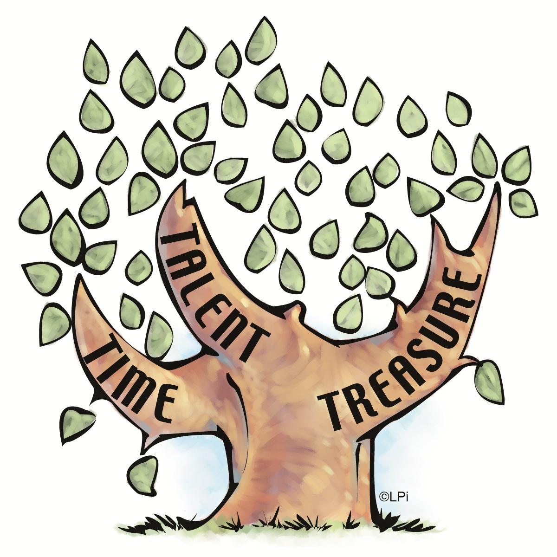

September starts Stewardship Month

Please Prayerfully think about what you can do for Christ

In the next Year.

**Murray Hill Presbyterian Church**

**Making His Purpose Count**

940 Talbot Avenue

Jacksonville, Florida 32205

(904) 389-2939

[www.mhpcjax.com](http://www.mhpcjax.com)

[mhpcjax@gmail.com](mailto:mhpcjax@gmail.com)

Rev. Samuel Bennett

September 14, 2025

**September 14, 2025**

Fourteenth Sunday after Pentecost

**Gathering God’s People**

Music for Gathering John Lansdale

Welcome and Announcements Beth Bozeman

**\*Call To Worship:**

Leader: Crowds gathered to hear Jesus speak of pain -

**People: the pain of losing something precious.**

Leader: Crowds gathered to hear Jesus speak of joy -

**People: the joy of finding what was lost.**

Leader: We gather to hear Jesus speak words of truth, words of power, words of love.

**People: Speak now, O God, for your servants are listening.**

**\***Song of Praise: *How Firm a Foundation #408*

Leader: Call to Confession

**Prayer of Confession**

Create in us clean hearts, O God, cast out any transgression you find there – ransack, renovate, redecorate! Deep in our hearts, remove fearful features and restore your original design. The old lamps are dim; bring new light into the darkness. Make your dwelling place deep in our hearts, and teach us wisdom, so the hearts you transform may rejoice.

**Declaration of Forgiveness**

The saying is sure and worthy of full acceptance, that Christ came into the world to save sinners. Believe the gospel.

**People: In Jesus Christ we are redeemed.**

**Passing the Peace of Christ:**

Leader: May the Peace of Our Risen Christ be with you!

**People: And also with you.**

Leader: Let us pass the peace of Christ.

(It is our custom to greet each other with the Peace of Christ.)

Song of Adoration: Make your way back to your seats and sing.

**\*Glory be to the Father, and to the Son and to the Holy Ghost, as it was in the beginning is now and ever shall be, world without end. Amen. Amen.**

*Song of Worship: *We’ve a Story to Tell to the Nations #446*

Pastoral prayer and Lord’s Prayer  Rev. Samuel Bennett

**Proclaiming the Word of God**

Scripture: Habakkuk 2: 1-3

Message: “Waiting” Rev. Samuel Bennett

**Offering**

Offering of our gifts and pledges

Offertory Music John Lansdale

*Doxology (Owens Arrangement) #814

Prayer of Dedication Rev. Samuel Bennett

**\*Sending**

*Song of Believers: There Is Power in the Blood #329

Benediction Rev. Samuel Bennett

Congregational Response  *God Be With You #232*

*Please stand for these parts of the service if you are able.