**Week of September 21 – September 28, 2025**

**Opportunities for Worship, Service, Study, and Fellowship:**

**Today:** Worship 10:45 am

Social time and refreshments after Worship

**Monday:** Christian Support Group Fellowship Hall 5:30 pm

**Tuesday:**

**Wednesday:** WSAA Fellowship Hall 7:00 pm

**Thursday:**

**Friday:**  Pillars of Faith Garden Room 6:30 – 9 pm

**Saturday:** Movie Night Fellowship Hall 5:30 pm

**Sunday:** Worship 10:45 am

Social time and refreshments after Worship

--------------------------------------------------------------------------------------------------------------------------------------

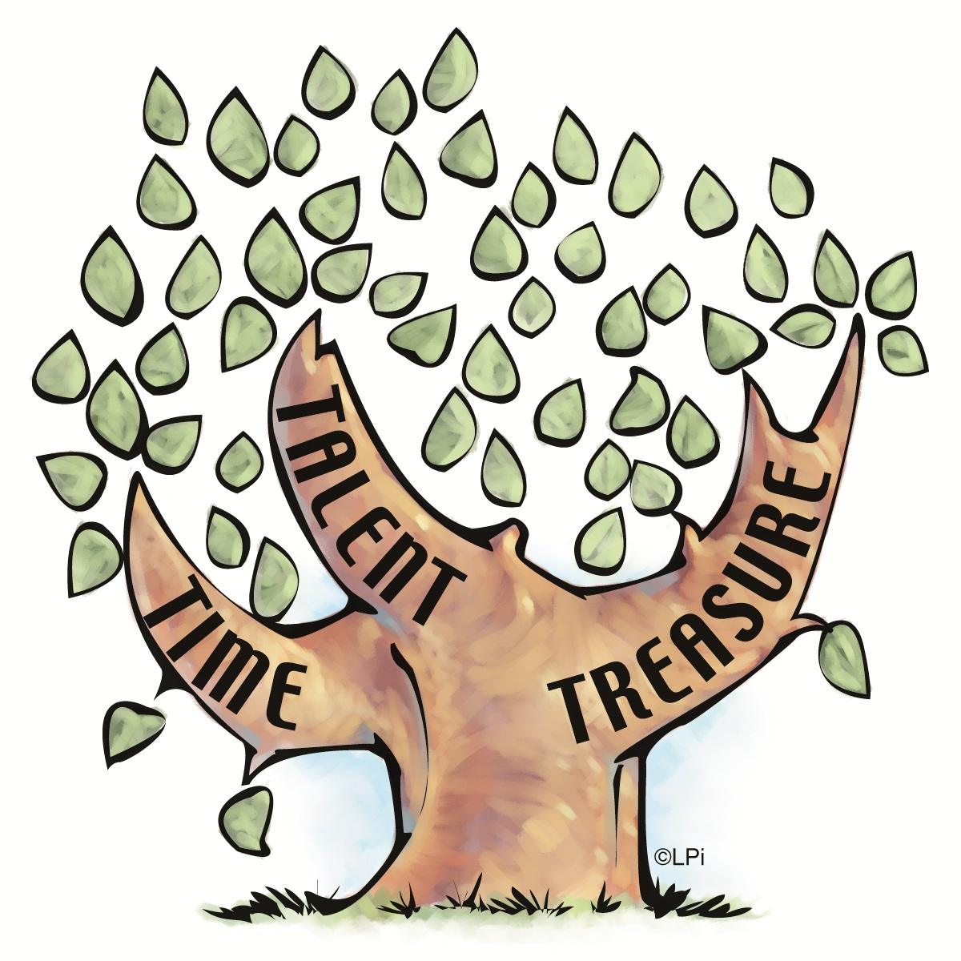

September starts Stewardship Month

Please Prayerfully think about what you can do for Christ

In the next Year.

Slips on the table.

**Murray Hill Presbyterian Church**

**Making His Purpose Count**

940 Talbot Avenue

Jacksonville, Florida 32205

(904) 389-2939

[www.mhpcjax.com](http://www.mhpcjax.com)

[mhpcjax@gmail.com](mailto:mhpcjax@gmail.com)

Rev. Jesse Bozeman

September 21, 2025

**September 21, 2025**

Fifteenth Sunday after Pentecost

**Gathering God’s People**

Music for Gathering John Lansdale

Welcome and Announcements Rev. Samuel Bennett

**\*Call To Worship:**

Leader: Beloved children of God, in supplication and prayer, with intercessions and with thanksgiving,

**People: we come to worship God.**

Leader: In hope and in humility, with joy and with concerns,

**People: we come to worship God.**

Leader: In faith and in uncertainty, with questions and with conviction,

**People: let us worship God.**

**\***Song of Praise: *In Christ There Is No East or West #428*

Leader: Call to Confession

**Prayer of Confession**

Holy God, we confess that we are too concerned with our own peace. We seek the comfort of silence and ignore the cries of the oppressed. We are inwardly focused, missing your call to serve the world in justice and love. Forgive us, O God. Equip us to fulfill your will for a world in which all know dignity and all are treated with equity, as your beloved children.

**Declaration of Forgiveness**

Leader: God our Judge is also our Savior. The good news is sure:

**People: in Jesus Christ, we are forgiven.**

Leader: May the Peace of Our Risen Christ be with you!

**People: And also with you.**

Leader: Let us pass the peace of Christ.

(It is our custom to greet each other with the Peace of Christ.)

Song of Adoration: Make your way back to your seats and sing.

**\*Glory be to the Father, and to the Son and to the Holy Ghost, as it was in the beginning is now and ever shall be, world without end. Amen. Amen.**

*Song of Worship: *Just a Closer Walk with Thee #564*

Pastoral prayer and Lord’s Prayer  Rev. Jesse Bozeman

**Proclaiming the Word of God**

Scripture: Psalm 79:1 - 9

Message: “Not Our Will but the Will of the Father” Rev. Jesse Bozeman

**Offering**

Offering of our gifts and pledges

Offertory Music John Lansdale

*Doxology (Owens Arrangement) #814

Prayer of Dedication Rev. Jesse Bozeman

**\*Sending**

*Song of Believers:  *The Old Rugged Cross #327*

Benediction Rev. Jesse Bozeman

Congregational Response  *God Be With You #232*

*Please stand for these parts of the service if you are able.