,

**Week of December 15 - December 22, 2024**

**Opportunities for Worship, Service, Study, and Fellowship:**

**Today:** Worship 10:45 am

Congregational Meeting after Worship

**Monday:**

**Tuesday:**

**Wednesday:** WSAA Fellowship Hall 7:00 pm

**Thursday:**

**Friday:**  Pillows of Faith Garden Room 6 to 9 pm

**Saturday:** Live Nativity 4:00 to 9 pm

**Sunday:** Worship 10:45 am Social Time and Snack after Worship

______________________________________________________________________________

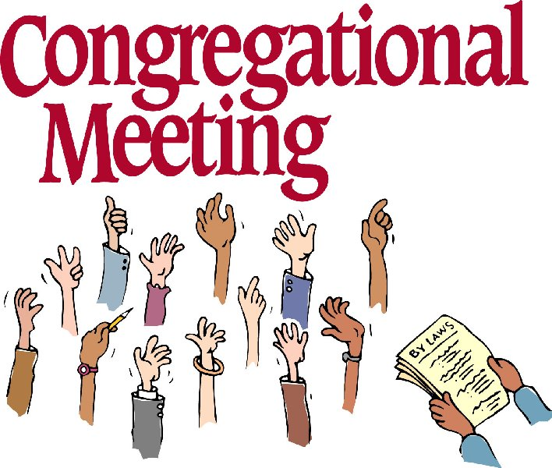

On January 8th we will have a congregational meeting to Ordain and install the new elders and present end of year report.

Murray Hill Presbyterian Church

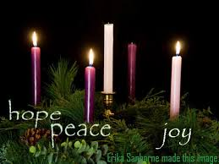

Making His Purpose Count

940 Talbot Avenue

Jacksonville, Florida 32205

(904) 389-2939

[www.mhpcjax.com](http://www.mhpcjax.com)

[mhpcjax@gmail.com](mailto:mhpcjax@gmail.com)

Rev. Samuel Bennett

December 15, 2024

**December 15, 2024**

Third Week of Advent

**Gathering God’s People**

Music for Gathering John Lansdale

Welcome and Announcements Beth Bozeman

**\*Call To Worship:**

**\*Call to Worship**.

Leader: Prepare the way of the Lord! Let us sing praises to the Lord, for God has done glorious things.

Let us shout aloud and sig for Joy, for great in our midst is thee Holy One of Israel, Come, let us

worship God.

**Lighting of the Advent Candle of Joy**

Leader: As we light our third Advent candle,

**People: we pray for hope, peace, and joy.**

Leader: Come now, O child of Mary.

**People: Come now, O Prince of Joy.**

**\*Song of Praise:**  *Joyful, Joyful, We Adore You #271*

Call to Confession:

**Prayer of Confession (in unison)**

Merciful God, we confess that, in the midst of your glorious creation, we have neglected our role in its care. We ignore the cries of the hurting and the lonely, those on the margins and those who are oppressed. We focus on our own desires, while forgetting the needs of our neighbors. We have not prepared a way for the Lord, through either our words or our deeds, neither through our actions nor our thoughts. Grant us your mercy in forgiveness; and lead us to act with compassion and justice, guided by you glorious light.

(Observe a time of silence for personal prayers of confession) **Amen**

**Declaration of Forgiveness:**

Leader: Surly God is our salvation! We will trust in the Lord’s goodness and will not be afraid. Know that you are forgiven and be at peace.

Passing the Peace of Christ:

Leader: May the Peace of Our Risen Christ be with you!

**People: And also with you.**

(It is our custom to greet one another at this time using the words above)

Song of Adoration (please find your way back to your seat as we sing together):

**\*Glory be to the Father, and to the Son and to the Holy Ghost, as it was in the beginning is now and ever shall be, World without end. Amen. Amen.**

**\*Song of Joy:** *Joy to the World #270*

Pastoral prayer and Lord’s Prayer Rev. Samuel Bennett

**Proclaiming the Word of God**

Scripture: Jeremiah 29: 11- 14

Message: “A Future and Hope” Rev. Samuel Bennett

**Responding to God’s Grace**

Offering of our lives and gifts

Offertory Music John Lansdale

*Doxology (Owens Arrangement) #814

Prayer of Dedication Rev. Samuel Bennett

**\*Sending**

**\*Closing Song:** *Angels We Have Heard on High* #278

Benediction Rev. Samuel Bennett

Congregational Meeting

**\*Please stand for these parts of the service if you are able**