Week of November 23 – November 30, 2025
Opportunities for Worship, Service, Study, and Fellowship:

Today: Worship 10:45 am
Congregational Meeting to elect elders.
Dinner after Worship
Greening of the Church after Dinner
Monday: Christian Support Group Fellowship Hall 5:30 pm
Tuesday:
Wednesday: WSAA Fellowship Hall 7:00 pm
Thursday: Thanksgiving at Church Fellowship Hall 1:00 pm
Friday: Pillars of Faith Garden Room 6:30 – 9 pm
Saturday: Movie Night Fellowship Hall 5;30 pm
Sunday: Worship 10:45 am Social Time and Snack after Worship
_______________________________________________________________________________
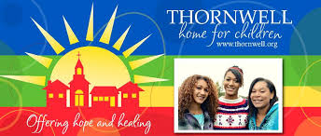
You will find envelope in the Narthex for your Thornwell offering.
You can place it in the offering basket when it is passed.

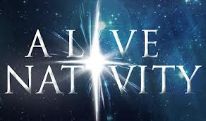

December 13 from 4-8
Remember this is our best opportunity as a church to spread the word of Christ and what he has done for us.

We also could use a few more Poinsettias for the Church, slips in bulletin

Murray Hill Presbyterian Church

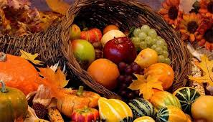

Making His Purpose Count

940 Talbot Avenue
Jacksonville, Florida 32205
(904) 389-2939
www.mhpcjax.com
mhpcjax@gmail.com

November 23, 2025

Rev. Samuel Bennett
November 23, 2025
Christ the King Day

Gathering God’s People

Music for Gathering John Lansdale
Welcome and Announcements Beth Bozeman
*Call To Worship:

Leader: God has looked favorably on all of God’s people and has redeemed all of creation.
People: God has given us a mighty Savior, the Lord whose reign we celebrate.
Leader: We gather to offer our thanks and praise to almighty God.
People: Let us worship God!

*Hymn The Holly and The Ivy handout

Leader: Call to Confession

Prayer of Confession

Gracious Lord, we are quick to identify our enemies and slow to name the ways we hurt others. You lead us in the ways of righteousness and yet we prefer to walk our own path. We are called to follow your lead in creating a beloved community, yet we idolize wealth and power. Heal us and help us, O God. Turn us from the ways of sin, the means that create unjust ends. Grant that we may seek to be
for others what you are for us: a source of light on the way to peace.

Declaration of Forgiveness

Leader: The Lord gives light to those who dwell in darkness and guides our every step in the path of salvation. In the name of Jesus Christ, we are forgiven.
People: Thanks be to God.

Passing the Peace of Christ:

Leader: May the Peace of Our Risen Christ be with you!
People: And also with you.
Let us pass the peace of Christ.

(It is our custom to greet one another at this time using the words above)

Song of Adoration (please find your way back to your seat as we sing together):

*Glory be to the Father, and to the Son and to the Holy Ghost, as it was in the beginning is now and ever shall be, world without end. Amen. Amen.

*Song of Worship: You Are My All in All #583

Pastoral prayer and Lord’s Prayer Rev. Samuel Bennett

Proclaiming the Word of God

Scripture: Psalms 103
Message: “Bless The Lord-O My Soul” Rev. Samuel Bennett

Offering
Offering of our gifts and pledges
Offertory Music John Lansdale
*Doxology (Owens Arrangement) #814
Prayer of Dedication Rev. Samuel Bennett

*Song of Believers: My Hope is in the Lord #540

Congregational Meeting
Rev. Jesse Bozeman

Benediction Rev. Samuel Bennett

Lunch in Fellowship Hall before we Green the Church

*Please stand for these parts of the service if you are able.

